FLYAWAY PROJECT

*Phase-2 Assessment Project by Jeevanantham M*

*Email id: jeevanantham.m@gmail.com*

# TABLE OF CONTENTS

[Project Introduction](https://docs.google.com/document/d/1GXPmFhqIFo5db4W-LIBF70mVoL9KjPraCswo4yy4_Z8/edit" \l "heading=h.o98zzcs3766h)

[Sprints planned](https://docs.google.com/document/d/1GXPmFhqIFo5db4W-LIBF70mVoL9KjPraCswo4yy4_Z8/edit" \l "heading=h.kpsgsnhcj8ts)

[Flowchart](https://docs.google.com/document/d/1GXPmFhqIFo5db4W-LIBF70mVoL9KjPraCswo4yy4_Z8/edit" \l "heading=h.bmnqg49vg3d)

[Technologies Used](https://docs.google.com/document/d/1GXPmFhqIFo5db4W-LIBF70mVoL9KjPraCswo4yy4_Z8/edit" \l "heading=h.95bsynyy55wr)

[Core Concepts in project](https://docs.google.com/document/d/1GXPmFhqIFo5db4W-LIBF70mVoL9KjPraCswo4yy4_Z8/edit" \l "heading=h.yl02p0ga8yxx)

[Conclusion](https://docs.google.com/document/d/1GXPmFhqIFo5db4W-LIBF70mVoL9KjPraCswo4yy4_Z8/edit" \l "heading=h.55rxwuxwlpz)

# PROJECT INTRODUCTION:

FlyAway is a simulation for ticket-booking portal that lets people book flights on their website.

Website Admin and Customer can use the same portal to achieve:-

## Admin operations:

* **Admin login** - which is authorised according to data in the database.
* **Change password** - Admin needs to enter the old password to authorise.
* **Manage Places**- Add, Delete, Update Places which can be added as Source or Destination later to  manage flights.
* **Manage airlines** - Add, Delete, Update Airlines which can be added as operating Airlines later to  manage flights.
* **Manage Flights** - Add, Delete, Update Flight Routes, Airlines and Prices from existing Place table and Airlines table in database.

## Customer Operations:

* Search Flights.
* Check existing Places and operating Airlines if desired flight doesn’t exist.
* Select a flight from search results.
* Confirm flight details like source, destination, date, no.of passengers, total price.
* Enter Customer Details.
* Pay for the displayed price.
* Confirm booking details.
* Redirect to Home Page.

# SPRINTS PLANNED

## List of Sprints:

* Planning (Flowchart)
* Design and Create DataBase
* Design Home page and Admin Login Page
* Login with User Validation, Design Admin Dashboard
* Manage Places(CRUD Operations)
* Manage Airlines(CRUD Operations)
* Manage Flights(CRUD Operations)
* Customer Search Flights in Home Page and Display Results from DB
* Ticket Booking with Dummy Payment.
* Testing for the Whole project.

# FLOWCHART

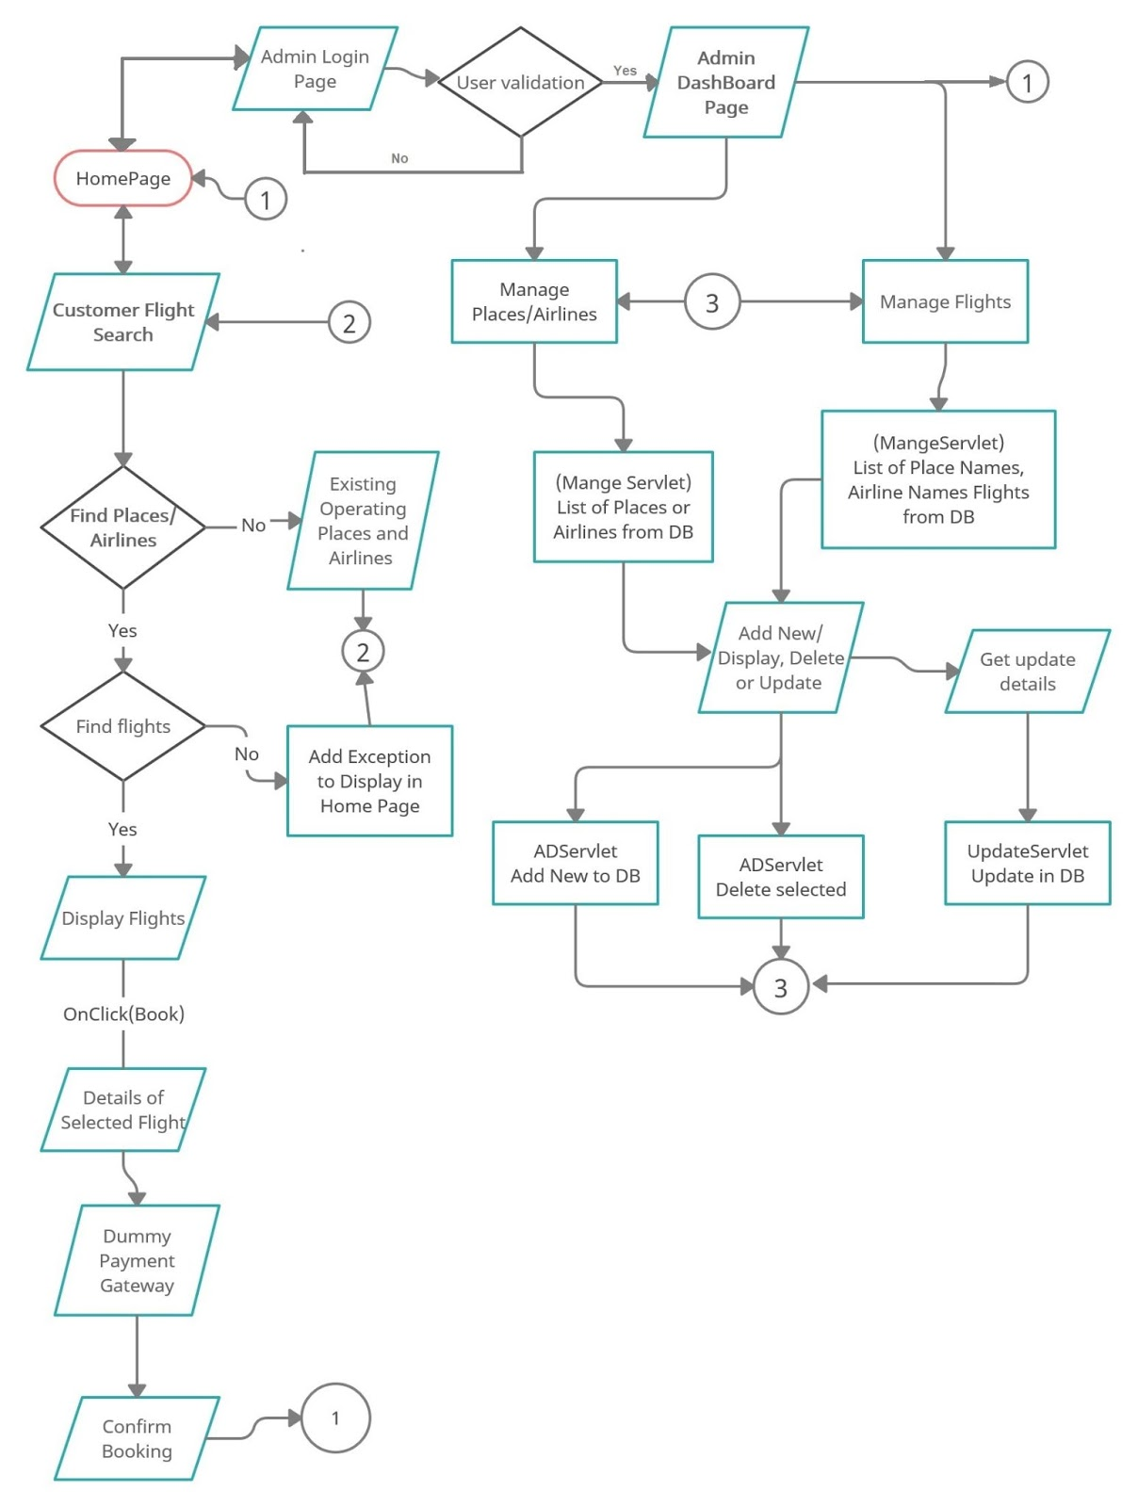

# TECHNOLOGIES USED:

* Eclipse IDE
* MySQL
* Java
* JSP
* Java Servlet
* Tomcat Server

# CORE CONCEPTS USED IN PROJECT

## MySQL:

CREATE, INSERT, SELECT, DELETE, UPDATE commands are used.

## JSP Elements:

Along with Regular HTML/CSS concepts like Tables, Forms, a href, div and many more I also used some important and required JSP concepts which are listed below.

* **Scriptlets:** To write regular java programs like if clause and Session properties like sessionTime, SesstionCreationTime.
* **Directives:** To include any other webpages like header, footer to existing page.
* **Expression:** Used to get and print Session Attributes.
* **JSTL tag <c:forEach>**: to iterate any list for printing.
* **JSTL tag <c:out>:** to print SessionAtribute Values sequentially.
* **JSTL tag <c:if>:** to restrict a value to print on webpage according to required conditions.

## Java Servlet:

Below listed concepts are mainly used along  with regular Servlet coding.

* **request.getParameter():** to get values from a webpage.
* **response.sendRedirect():** redirect to desired webpage
* **response.setHeader():** to display “Session expired” message and redirect to HomePage after a certain time(5seconds).
* **session.setAttribute():** method from HttpSession to set session values.
* **RequestDispatcher:** mainly to Include any webpage with desired message or Alert.
* **out.print()**: To print something on a webpage directly from servlet.

## Core Java Concepts:

Along with basic concepts of Java like Output stmts, keyboard input, object, for loop, if statements and more, I also used:-

* **Connection Interface:** to establish connection between java and Database.
* **Exceptions:** to deal with unexpected errors and display the same on the webpage.
* **List<>()**: Used to save data values from database
* **PreparedStatement**: Execute SQl query using Connection and ResultSet and also used to save the result in variables or Lists.

# CONCLUSION:

This FlyAway unique points are:

* In Admin Operations while working with Place or Airlines. If any user deletes a Place or an Airline all related flights will also get deleted in the Flight List.
* In Admin Operations while adding Flight’s Source, Destination and Airline, the PlaceNamesList and AirlineNamesList will be fetched dynamically from Place table and Airlines Table from DataBase.
* Customers are given an extra option to select either of any options from (Economy Class, First Class or Business Class) while entering basic details for searching flights.
* Flight Search Results are displayed only according to class they selected.

**THANK YOU**